 | TABLE OF CONTENTS
1. Title of the Project |  | 4
2. Abstract |  | 5
3. Introduction |  | 7
4. Problem Statement |  | 8
5. Literature Survey |  | 9
6. Objectives of the Project |  | 11
7. Methodology Followed |  | 12
8. Outcome of the Project |  | 15
9. Summary |  | 16
10. References |  | 17

AI POWERED INTRUSION
DETECTION AND PRIVACY
RESERVATION IN 6G NETWORKS

ABSTRACT
The rapid development of next-generation communication systems such as 6G networks introduces significant security challenges due to the massive number of connected devices, high data transmission rates, and distributed network architectures. Traditional centralized intrusion detection systems often struggle to handle large-scale network traffic while maintaining user data privacy. This project proposes an AI-powered intrusion detection system (IDS) that integrates Federated Learning and Differential Privacy to enhance both security and privacy in 6G environments. A Convolutional Neural Network (CNN) model is employed to learn complex patterns in network traffic and classify malicious and benign activities. Instead of transferring sensitive network data to a centralized server, federated learning enables multiple edge nodes to collaboratively train the model locally while sharing only model parameters. To further protect sensitive information, differential privacy mechanisms are applied to the model updates by adding controlled noise before aggregation, preventing potential leakage of user data. The system is evaluated using the CSE-CIC-IDS2018 dataset, which provides realistic and modern network attack scenarios.The proposed framework aims to improve intrusion detection accuracy while preserving user privacy in distributed network environments. This approach demonstrates the potential of combining deep learning and privacy-preserving techniques to build secure and scalable intrusion detection systems suitable for future 6G communication networks.

1.INTRODUCTION
The rapid evolution of wireless communication networks toward 6G promises ultra-high data rates, massive device connectivity, and ultra-low latency. However, this introduces significant security and privacy challenges, as cyber-attacks such as DDoS, botnets, and infiltration can compromise network reliability and sensitive user data. Traditional intrusion detection systems are often centralized and struggle to handle the massive, distributed traffic of next-generation networks while also posing privacy risks.To address these challenges, AI-powered intrusion detection systems have emerged as a promising solution. Deep learning models, such as Convolutional Neural Network (CNN), can automatically learn complex patterns in network traffic to detect malicious activity. However, conventional AI approaches require centralized data collection, which may expose sensitive information.This motivates the integration of Federated Learning and Differential Privacy. Federated learning allows multiple network nodes to collaboratively train a model without sharing raw data, while differential privacy adds controlled noise to model updates to further protect sensitive information.This project represents a comprehensive approach to privacy-preserving, AI-powered intrusion detection in 6G networks. It demonstrates how deep learning, federated learning, and differential privacy can be combined to build a secure, scalable, and distributed IDS capable of detecting modern cyber-attacks while preserving user privacy. The system is evaluated using the CSE-CIC-IDS2018, which contains realistic network traffic and contemporary attack scenarios, making the results applicable to next-generation communication networks. Here’s why it is important:
• Next-Generation Network Security: 6G networks connect billions of devices, increasing vulnerability to cyber-attacks; an AI-based IDS ensures real-time threat detection.
• Privacy Preservation: Sensitive network data is protected using Federated Learning and Differential Privacy, preventing data leakage.
• Handling Distributed Data: Federated learning enables local model training at edge nodes, making the system scalable for high-volume, heterogeneous traffic.
• Detection of Modern Cyber Threats: Deep learning models like CNNs can identify complex patterns, detecting both known and evolving attacks effectively.
• Realistic Evaluation: Using CSE-CIC-IDS2018 ensures the system is tested on modern, real-world attack scenarios, not just theoretical data.
• Contribution to 6G Research: Integrates AI, distributed learning, and privacy-preserving techniques, demonstrating a practical solution for secure 6G networks.

2.PROBLEM STATEMENT
With the rapid growth of 6G networks, the volume, velocity, and variety of network traffic are increasing dramatically. This creates significant challenges in detecting malicious activities, such as DDoS attacks, botnets, and network infiltration, in real time. Traditional intrusion detection systems rely on centralized data collection and signature-based detection, which are often insufficient for large-scale, distributed, and high-speed networks.Moreover, centralizing network traffic for AI model training raises serious privacy concerns, as sensitive user data can be exposed or misused. Existing AI-based intrusion detection models struggle to balance accuracy, scalability, and privacy preservation simultaneously.This project addresses these challenges by developing a privacy-preserving AI-powered intrusion detection system for 6G networks. It combines deep learning (CNN) for attack detection, Federated Learning for distributed training, and Differential Privacy for safeguarding sensitive data, providing a scalable and secure solution for next-generation networks.
Problem Statement:
“Traditional intrusion detection systems struggle to detect modern cyber-attacks in 6G networks while preserving user privacy, necessitating a scalable AI-based IDS using federated learning and differential privacy.”

3.LITERATURE SURVEY
Intrusion detection research has evolved from early datasets like KDD Cup 1999 and NSL-KDD, which used machine learning models such as SVMs, Random Forests, and basic neural networks to detect attacks. While these datasets were useful for benchmarking, they are outdated and do not represent modern network traffic or contemporary attack patterns, making them insufficient for evaluating AI-based intrusion detection systems in next-generation networks. More recent datasets like CICIDS2017 and CSE-CIC-IDS2018 provide realistic network flows with diverse attack types, including DDoS, botnets, and multi-step intrusions, making them suitable for deep learning models such as CNNs, LSTMs, and hybrid approaches. CNNs effectively capture correlations between features, while LSTMs address temporal dependencies, enabling more accurate detection of complex attacks.With the growing deployment of 6G networks and edge computing, privacy has become a major concern. Centralized AI-based IDS require aggregating s ensitive network data, creating risks of data leakage. To address this, Federated Learning (FL) allows collaborative model training across distributed nodes without sharing raw data, and Differential Privacy (DP) adds controlled noise to model updates to prevent information leakage. Recent studies suggest that combining CNN-based IDS with FL and DP provides a scalable, privacy-preserving solution suitable for massive, heterogeneous 6G networks. However, there is limited research that integrates all three techniques into a single framework, highlighting the relevance and novelty of this project.

3.1 Existing System
Traditional intrusion detection systems (IDS) are primarily signature-based or anomaly-based and rely on centralized data collection. Signature-based systems compare network traffic against known attack patterns, which makes them ineffective against new or evolving attacks. Anomaly-based systems use statistical or machine learning methods to detect deviations from normal behavior, but they often require centralized datasets, which raises privacy concerns and limits scalability in large, distributed networks like 6G. Earlier AI-based IDS approaches have used datasets such as KDD 1999 and NSL-KDD with machine learning models like SVMs, Random Forests, and simple neural networks. While these methods were effective for small-scale networks, they struggle with modern traffic volumes and complex attack patterns, and they do not account for privacy preservation. Even more recent approaches using CICIDS2017 and UNSW-NB15 datasets provide improved accuracy, but most still rely on centralized training, leaving sensitive network data exposed and making them less suitable for distributed 6G networks.

3.2 Proposed System
The proposed system is a privacy-preserving AI-powered intrusion detection system (IDS) designed for 6G networks. It integrates Convolutional Neural Network (CNN) for detecting complex attack patterns, Federated Learning for distributed model training, and Differential Privacy to ensure user data remains secure during training.In this system, network traffic data is collected locally at edge nodes or base stations and used to train a CNN model. Instead of sending raw data to a central server, only model updates are shared, preserving privacy. Differential privacy is applied by adding controlled noise to the model parameters, preventing sensitive information from being inferred. A central server then aggregates the updates using federated averaging, producing a global model capable of accurately detecting malicious activity. The system is evaluated using the CSE-CIC-IDS2018, which provides realistic modern attack scenarios.This approach addresses the limitations of existing systems by providing a scalable, distributed, and privacy-preserving solution, capable of detecting contemporary cyber-attacks in high-speed, device-dense 6G networks.

OBJECTIVES OF THE PROJECT

The main objective of this project is to develop a privacy-preserving, AI-powered intrusion detection system for 6G networks. The system leverages a Convolutional Neural Network (CNN) to accurately detect modern cyber-attacks, while Federated Learning enables distributed model training across multiple edge nodes without sharing raw data. To further protect sensitive information, Differential Privacy is applied to model updates, ensuring that user data remains secure during collaborative learning. The proposed framework is evaluated using the CSE-CIC-IDS2018 dataset, providing a scalable, secure, and practical solution for detecting cyber threats in high-speed, device-dense 6G network environments.

The objectives of this project are as follows:
Objective 1: Develop an AI-based Intrusion Detection System.
Build a CNN model capable of detecting modern cyber-attacks, including DDoS, botnets, and infiltration.
Objective 2: Implement Distributed Training with Federated Learning.
Enable multiple edge nodes to train the model locally without sharing raw network data, improving scalability and security.
Objective 3: Incorporate Differential Privacy.
Apply controlled noise to model updates to protect sensitive user information during collaborative training.
Objective 4: Evaluate Using Realistic Datasets.
Test and validate the system using CSE-CIC-IDS2018, which contains modern attacks and realistic traffic pattern
Objective 5:Provide a Scalable and Privacy-Preserving Solution for 6G Networks
Ensure the IDS can handle high-volume, distributed network traffic while maintaining user privacy and detection accuracy.

5.METHODOLOGY FOLLOWED
The proposed project follows a systematic approach to design a privacy-preserving AI-powered intrusion detection system for 6G networks. The system begins with the CSE-CIC-IDS2018 dataset, which contains realistic network traffic with both normal and malicious flows. The data is preprocessed by handling missing values, normalizing features, and converting categorical attributes into numerical representations suitable for AI models. Relevant flow-based features, such as packet size, duration, and protocol type, are selected to reduce dimensionality while retaining critical information for detecting attacks.A Convolutional Neural Network (CNN) is then developed to automatically learn patterns in network traffic, with layers and hyperparameters optimized for accurate classification of normal and malicious flows. To ensure privacy, the model is trained using Federated Learning, where multiple edge nodes or base stations train the CNN locally on their own data without sharing raw traffic. Differential Privacy is applied by adding controlled noise to the model updates before sending them to a central server, preventing sensitive information from being inferred. The central server aggregates the updates using Federated Averaging, producing a global model that improves iteratively over successive training rounds.The system is evaluated using metrics such as accuracy, precision, recall, F1-score, and detection rate. Its performance is compared with baseline centralized and non-privacy-preserving models to demonstrate effectiveness. Finally, the methodology ensures that the IDS framework is scalable and suitable for 6G networks, capable of handling high-volume, heterogeneous, and distributed network traffic while preserving user privacy.

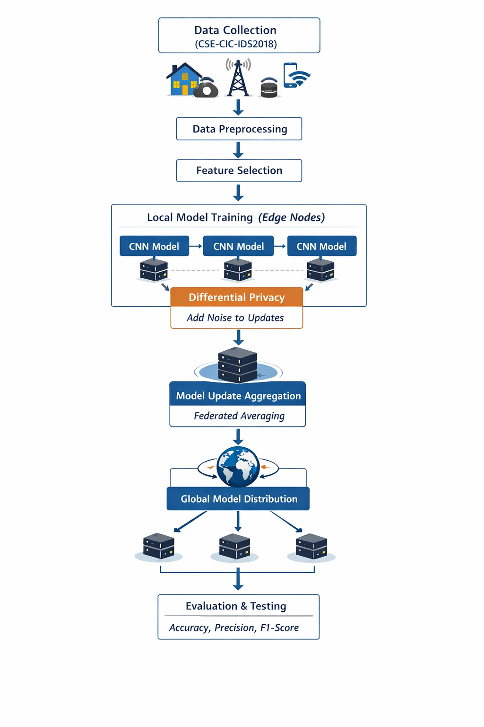

Fig 5.1 Privacy Preserving Intrusion detection in 6G
The flowchart illustrates the workflow of a privacy-preserving AI-powered intrusion detection system for 6G networks. It begins with data collection using the CSE-CIC-IDS2018 dataset, followed by preprocessing and feature selection to prepare the data for training. Each edge node trains a CNN model locally, capturing patterns in normal and malicious network traffic. Differential Privacy is applied by adding controlled noise to the model updates, protecting sensitive user information. The updates are then sent to a central server, where Federated Averaging aggregates them into a global model, which is redistributed to all nodes for further training. Finally, the system is evaluated using metrics such as accuracy, precision, and F1-score, ensuring the IDS is both effective and privacy-preserving for high-volume, distributed 6G networks.

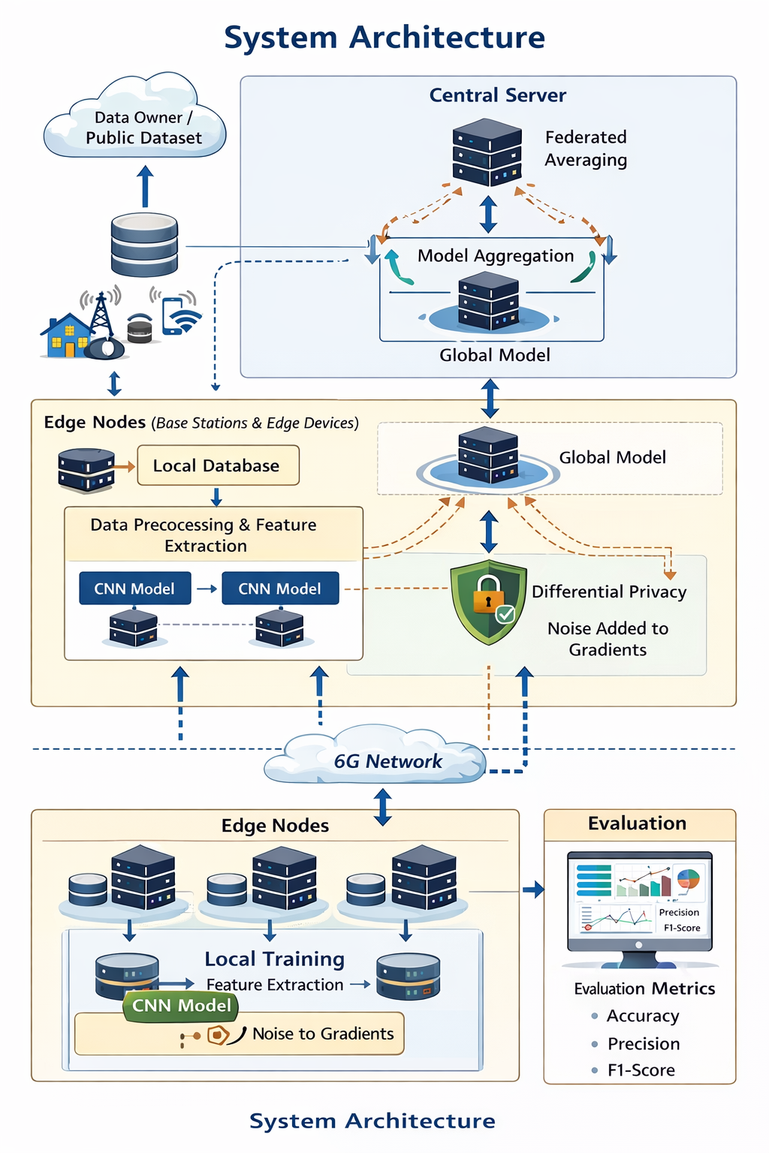

Fig 5.2 System Architecture

The system architecture illustrates a privacy-preserving AI-powered intrusion detection system for 6G networks. Network traffic is collected at multiple edge nodes, such as base stations and IoT devices, and stored in local databases. Each node performs data preprocessing and feature extraction before training a CNN model locally. Differential Privacy is applied by adding controlled noise to the model updates to ensure sensitive data is protected. The updates are sent to a central server, where Federated Averaging aggregates them into a global model, which is redistributed to all nodes for further training. The system is evaluated using metrics such as accuracy, precision, and F1-score, ensuring it is both effective in detecting cyber-attacks and secure for distributed, high-volume 6G network environments

6.OUTCOME OF THE PROJECT
The outcome of this project is the development of a privacy-preserving AI-powered intrusion detection system suitable for next-generation 6G networks. The system uses a Convolutional Neural Network to accurately identify malicious network activities such as DDoS, botnets, and other cyber-attacks. By incorporating Federated Learning, the model can be trained across multiple edge nodes without sharing raw network data, ensuring scalability and distributed learning. Additionally, Differential Privacy protects sensitive information by adding controlled noise to model updates during training. As a result, the proposed system provides an efficient, scalable, and privacy-preserving solution capable of detecting cyber threats in high-speed and device-dense 6G network environments while maintaining strong data security.
Outcomes of the Project:
1.Development of an AI-Based Intrusion Detection System:
A functional IDS using Convolutional Neural Network capable of identifying malicious and normal network traffic.
- Privacy-Preserving Distributed Learning Framework:
Implementation of Federated Learning to enable collaborative model training across multiple nodes without sharing raw data.
3.Enhanced Data Security Mechanism:
Integration of Differential Privacy to protect sensitive user information during model updates.
4.Improved Detection Performance:
Achieving high performance in detecting cyber-attacks using evaluation metrics such as accuracy, precision, recall, and F1-score.
5.Scalable Solution for Future 6G Networks:
A system architecture capable of handling large-scale, distributed network traffic, making it suitable for next-generation communication environm

7.SUMMARY
With the rapid advancement of wireless communication technologies, 6G networks are expected to support extremely high data rates, ultra-low latency, and massive connectivity for billions of devices. However, this rapid growth also introduces significant security and privacy challenges, as cyber-attacks such as DDoS, botnets, and infiltration attempts can threaten network reliability and sensitive user information. Traditional intrusion detection systems often rely on centralized architectures and signature-based methods, which may struggle to handle large-scale distributed traffic and may expose sensitive network data during analysis.This project proposes a privacy-preserving AI-powered intrusion detection system designed specifically for next-generation 6G networks. The system utilizes a Convolutional Neural Network to analyze network traffic patterns and accurately detect malicious activities. To address privacy concerns, Federated Learning is implemented, allowing multiple edge nodes to collaboratively train the AI model without sharing raw network data. In addition, Differential Privacy is incorporated to protect sensitive information by adding controlled noise to model updates during training.The system is evaluated using the CSE-CIC-IDS2018, which provides realistic network traffic and modern cyber-attack scenarios. Through this approach, the project aims to develop a secure, scalable, and distributed intrusion detection framework capable of detecting advanced threats while preserving user privacy. Overall, the proposed solution demonstrates how the integration of artificial intelligence and privacy-preserving techniques can strengthen cybersecurity in future 6G communication networks.

REFERENCES

- Hua, B., & Xi, H., “A Privacy-Preserving Intrusion Detection Framework for 6G Networks Using Homomorphic Encryption and Graph Neural Networks,” Scientific Reports, vol. 16, 2026.
- Soomro, I. A., Rehman, H. U., Hussain, S. J., Iqbal, A., Khalid, W., & Yu, H., “SecureDyn-FL: A Robust Privacy-Preserving Federated Learning Framework for Intrusion Detection in IoT Networks,” 2026.
- Izadi, S., & Ahmadi, M., “Lightweight Cluster-Based Federated Learning for Intrusion Detection in Heterogeneous IoT Networks,” 2026.
- B. Hua and H. Xi, “A Privacy-Preserving Intrusion Detection Framework for 6G Networks Using Homomorphic Encryption and Graph Neural Networks,” Scientific Reports, vol. 15, 2025.
- S. P. Praveen, K. Sharma, and D. Parashar, “Design of an Iterative Method for Adaptive Federated Intrusion Detection for Energy-Constrained Edge-Centric 6G Cyber-Physical Systems,” Scientific Reports, 2025.
- H. Yan, X. Pang, S. Zhou, and H. Fan, “Transformer-Based Intrusion Detection for Post-5G and 6G Telecommunication Networks Using Dynamic Semantic Embedding,” Future Internet, vol. 17, no. 12, 2025.
- J. Zhang, C. Luo, Y. Jiang, and G. Min, “Security in 6G-Based Autonomous Vehicular Networks: Detecting Network Anomalies With Decentralized Federated Learning,” IEEE Vehicular Technology Magazine, 2025.
[8] M. Gupta, R. K. Jha, and M. Sabraj, “Security Challenges in 6G Networks: A Game Theory-Based Intrusion Detection with Network Slicing and AI/ML Perspectives,” 2024.

